DAYS 12–13
Log Analysis Fundamentals
// 01 OVERVIEW & SCOPE

Log analysis is the core daily skill of a SOC analyst — pulling relevant information from multiple sources, correlating it across time, and building a coherent picture of what happened. This report covers findings across two log sources: Linux authentication/system logs (auth.log, syslog) via Wazuh, and Windows Event Log data from the Windows 10 agent, focused on three event IDs: 4625 (failed logon), 4720 (account creation), and 4672 (special privilege use).

$ Sources Covered
- Linux — /var/log/auth.log & /var/log/syslog: authentication events (SSH logins, sudo usage, user switching) and general system events, reviewed via Wazuh Security Events filtered to Linux agents.
- Windows — Event Log via Wazuh: Event ID 4625 (failed login), 4720 (new account creation), and 4672 (special privilege use), reviewed via Wazuh Security Events filtered to the Windows 10 agent.

$ Deliverables in This Report
- Log analysis findings, structured by source then event type — raw detail, interpretation, and investigation verdict for each.
- CSV export of critical events across the week (FIM, custom rule triggers, failed logins, privilege use, account creation).
- Chronological timeline of every event this week worth flagging in a real environment.

// 02 LINUX — FAILED AUTHENTICATION FINDINGS

Reviewed via Wazuh Security Events, filtered to Linux agents and rule.groups: authentication_failed, including the custom SSH brute-force rule (100002) built in Days 10-11.
$ Query Used
agent.name: <linux-agent>
rule.groups: authentication_failed
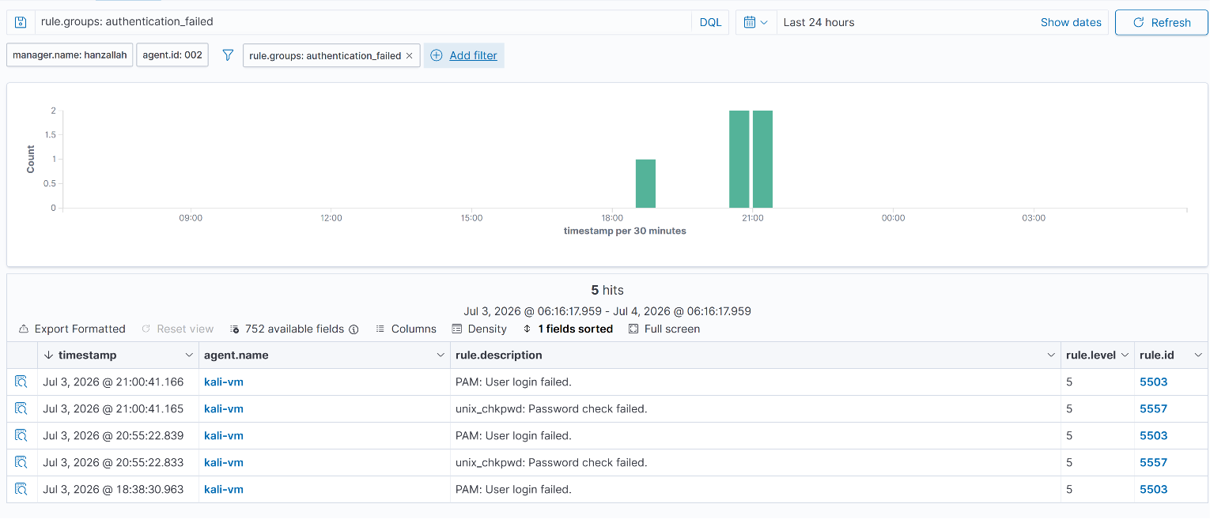
Wazuh Security Events — Linux auth failure cluster, filtered view

$ Findings
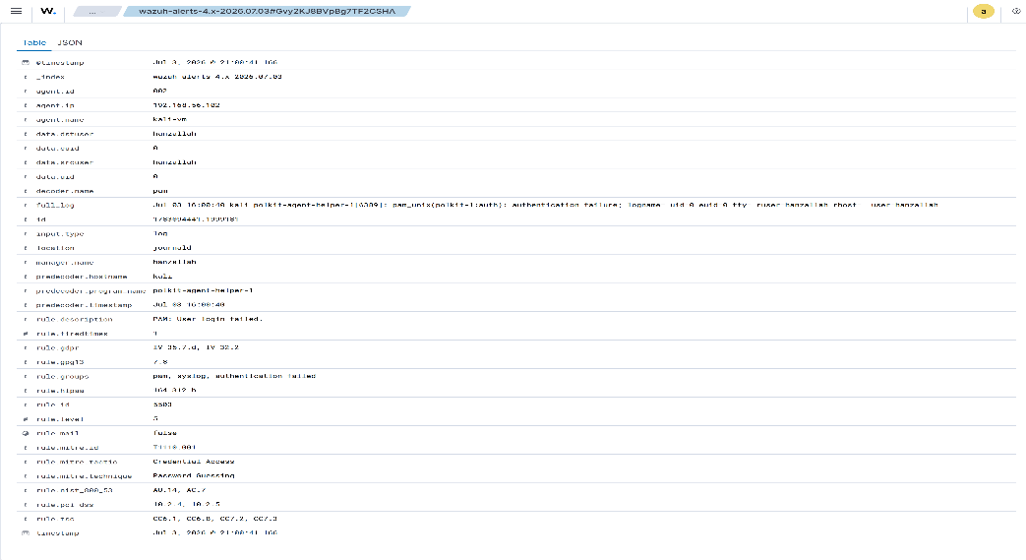
Expanded alert JSON — Linux auth failure detail
// 03 WINDOWS — EVENT ID 4625 (FAILED LOGON)

Reviewed via Wazuh Security Events, filtered to the Windows 10 agent and data.win.system.eventID: 4625. Test data generated via SMB connection attempts from Kali using both a valid username with a wrong password and a nonexistent username, to compare failure reason codes.
$ Query Used
agent.name: win10-vm
data.win.system.eventID: 4625
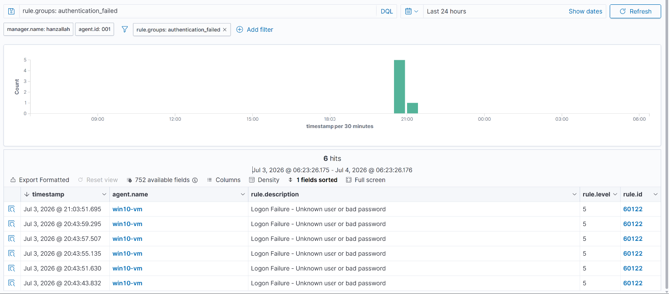
Wazuh Security Events – 4625 result list (rule 60122,T1531)
$ Findings
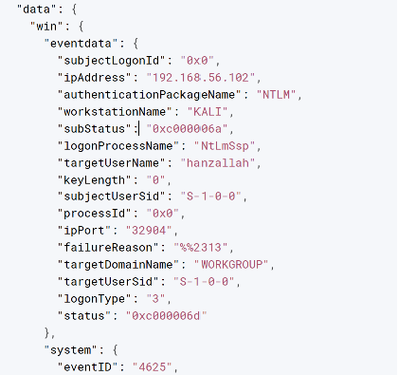
Expanded alert JSON — 4625 detail, bad password case (subStatus 0xC000006A)

// 04 WINDOWS — EVENT ID 4720 & 4672

$ 4720 — New Account Creation
This event should correspond to the test user account created during Days 10-11 rule testing.
agent.name: win10-vm
data.win.system.eventID: 4720
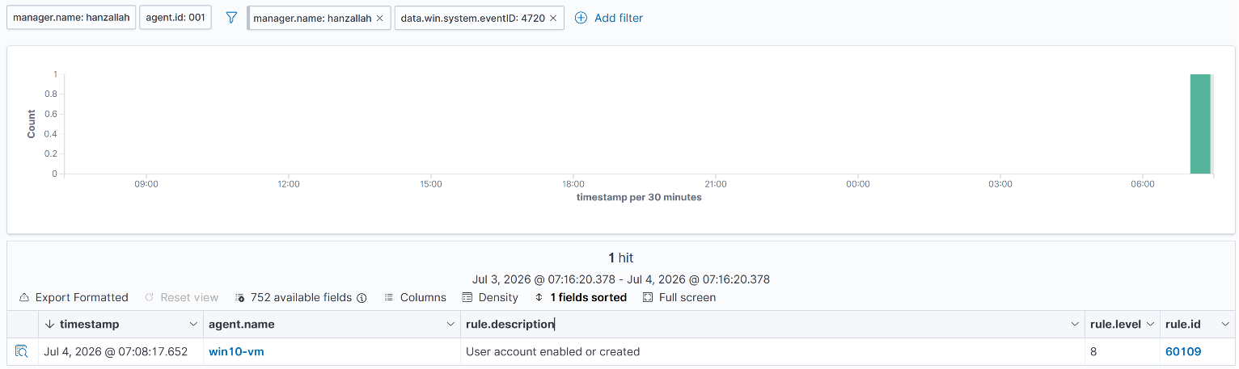
Wazuh Security Events — 4720 alert detail (account created, by whom, when)

$ 4672 — Special Privilege Use
Fires on administrator logins and service accounts with elevated rights. The key analytical move is correlation: a 4625 failure immediately followed by a 4672 success from the same source is a strong signal someone guessed a password and got in.
agent.name: win10-vm
data.win.system.eventID: 4672
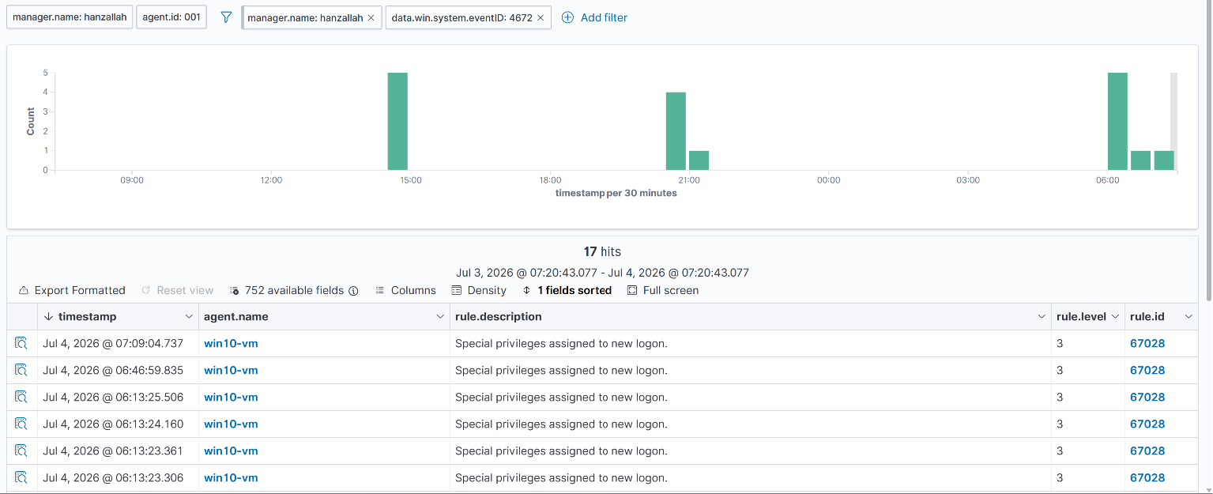
Wazuh Security Events — 4672 alert detail
// 05 THREAT HUNTING — CROSS-SOURCE CORRELATION

Used the Threat Hunting module to query across agents in a single view and look for a coherent multi-step sequence — e.g. failed SSH attempts on the Linux agent followed by a successful login.
$ Query Used
rule.id: 100002 OR (agent.name: hanzallah AND data.dstuser: hanzallah)
Time range narrowed to the exact window of the Days 10-11 SSH brute-force test.
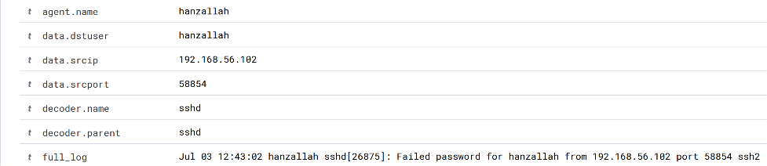
Threat Hunting module — correlated timeline view, brute-force sequence

// 06 CSV EXPORT OF CRITICAL EVENTS

Exported a query covering the week's most significant events — failed logins, privilege use, account creation, FIM alerts, and custom rule triggers — for handoff to a manager or SIEM engineer.
$ Query Used for Export
rule.level: >=7
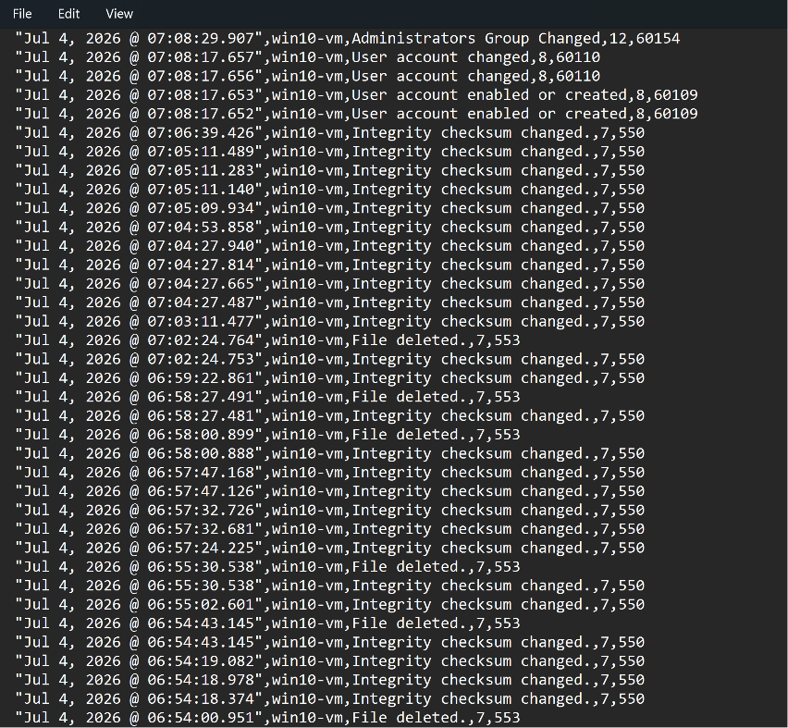

// 07 TIMELINE OF SUSPICIOUS ACTIVITY

Every event from this week considered worth flagging in a real environment, in chronological order — the starting point for what would become a formal incident report.

TIMESTAMP | EVENT DESCRIPTION | AGENT | WHY FLAGGED
TBD | FIM: /etc/fim_test.txt created/modified/deleted | Ubuntu-Server-Wazuh | Baseline FIM validation — expected, not malicious
TBD | Custom rule 100010: new user account created | Ubuntu-Server-Wazuh | Deliberate test of account-creation detection
TBD | Custom rule 100011: SSH brute force, 6+ failures | Ubuntu-Server-Wazuh | Deliberate brute-force simulation from Kali
TBD | Custom rule 100012: USB device inserted | Windows-11-Host | Deliberate test of removable-media detection
TBD | 4625: failed logon(s) | win10-vm | TBD — bad password vs. enumeration, see Section 03
TBD | 4720: account created | win10-vm | Confirms Days 10-11 test account creation logged correctly
TBD | 4672: special privilege use | win10-vm | TBD — checked for adjacency to 4625 failures, see Section 04

